**R Data Visualization Types :**

1. R - Pie Charts
2. R - Bar Charts
3. R – Boxplots
4. R – Histograms
5. R - Line Graphs
6. R – Scatterplots

**Parameter :**

labels=as.character(expenditure),

main="Monthly Expenditure Breakdown",

col=c("red","orange","yellow","blue","green"),

border="brown",

clockwise=TRUE

xlab = "Degree Celsius",

ylab = "Day",

names.arg = c("Sun", "Mon", "Tue", "Wed", "Thu", "Fri", "Sat"),

col = "darkred",

horiz = TRUE

density=10

**R - Pie Charts**

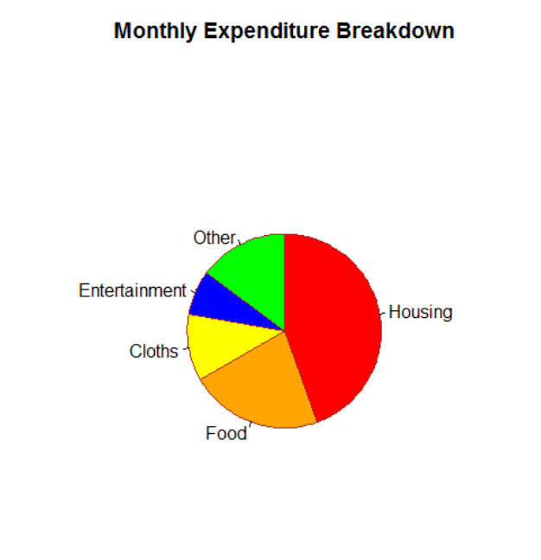

**R - Bar Charts**

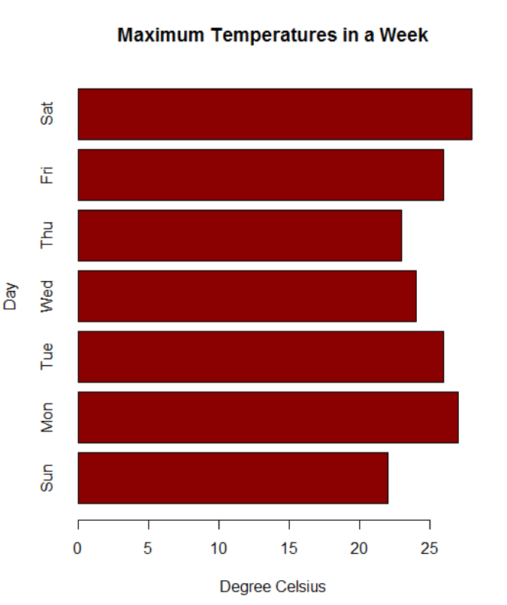

**R – Boxplots**

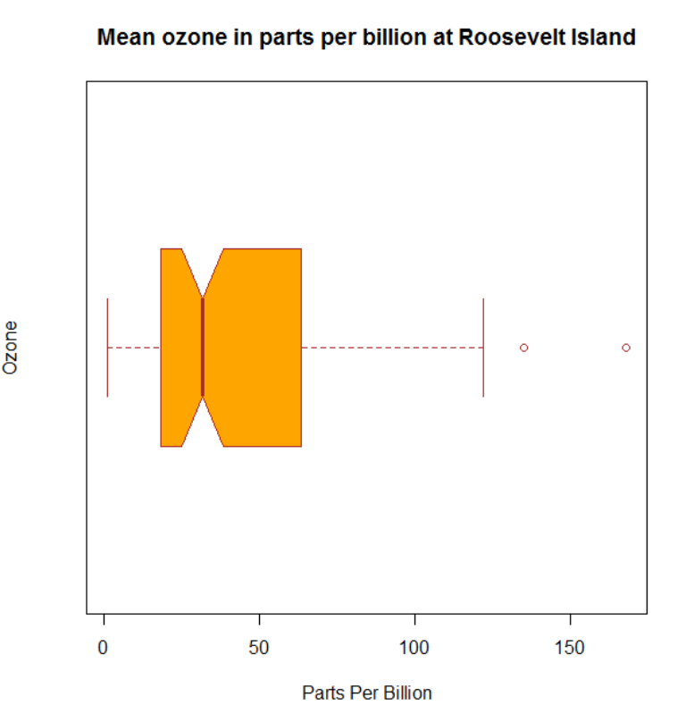

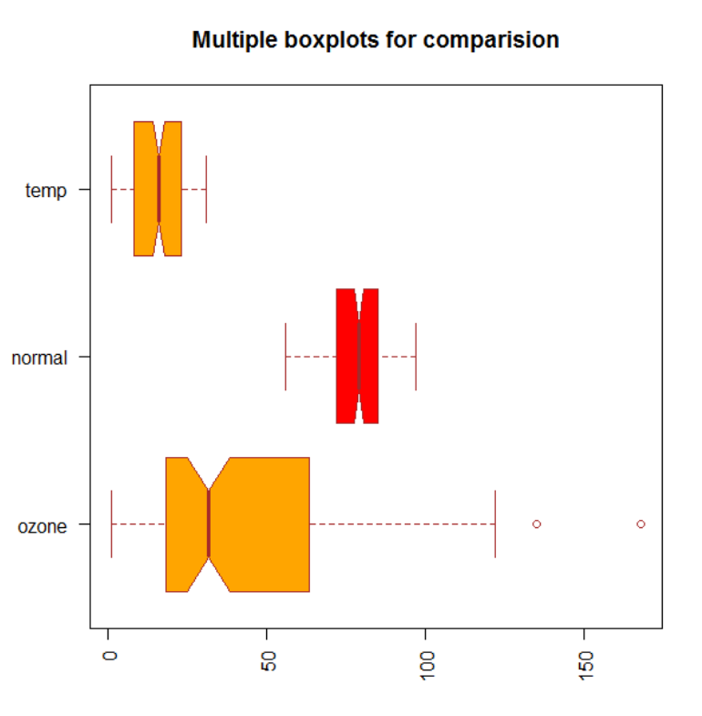

**R – Histograms**

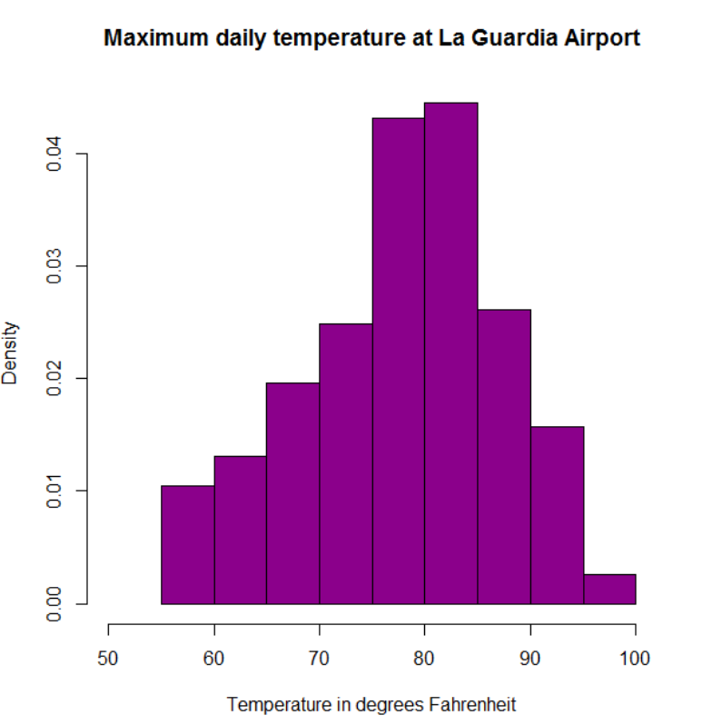

**R - Line Graphs**

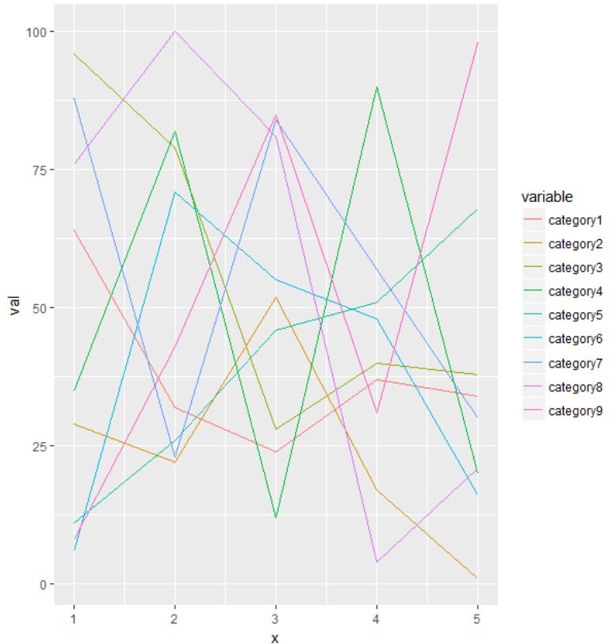

**R – Scatterplots**

